  
**McAllen MRI Center**  
320 North McColl Rd. E  
McAllen, TX 78501  
Phone: (956)-687-9636 Fax: (956)-687-9743

------------------------------------------------------------------------------------------------------------  
**NAME:** danny **Date of Exam:** 03/31/92  
**DOB:** 01/01/17 **Medical Record:** SOMETHING  
**Referral Dr:** AK   
**Procedure:** N/A  
  
**History:**   
  
------------------------------------------------------------------------------------------------------------

Thank you for your referral  
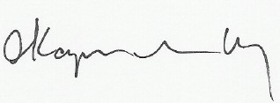  
Electronically signed by:  
Allan Kapilivsky M.D.  
Reviewed and dictated the same day